Optical Feedback of Focused Augmented Mirror-based Facial Makeup System

Ja Hu Ku, Jae Seok Jang, Soon Ki Jung

School of Computer Science and Engineering, Kyungpook National University
80 Daehakro, Buk-gu
Daegu, Republic of Korea
jhku@vr.knu.ac.kr, jsjang@vr.knu.ac.kr, skjung@knu.ac.kr

Abstract

This research began with the idea of using a mirror, which is common in our life, as a device of Augmented Reality (AR) to support the general service of facial makeup. Focused Augmented Mirror (FAMirror) is a system of one-way mirrors with a certain degree of transparency in a certain direction, and a display behind them [1]. The mirror reflects original image of user on its surface, and the projected image from display behind of mirror merged on the surface of mirror, in order to provide an augmented image for user. This paper deals with optical feedback to minimize user's sense of incompatibility in facial make-up service using FAMirror. In the makeup section, there is a benefit obtained by blending users’ original face image with the cloned original image converted in HSV format with edited hue & saturation, rather than blending with simple RGB plain data in make-up process. The Matching Position adjusts the position of the image output from the screen behind the mirror to overlap on the original image reflected on the mirror surface with the image of the user taken by the depth-camera. The Color Adjustment works for recovering the original color data, lost due to the transmittance characteristic of one-way mirror and the external environment factor. It measures the error in blended image on mirror surface with a separated camera when using the system for the first time, then it builds a feedback set that allows continuous color correction without additional camera. This study provides user-friendly services with three types of optical feedback that support FAMirror and presents directions of human stereo vision error correction, or more accurate color adjustment for advanced service.
Keywords- half-mirror; face-detection; virtual cosmetic; color adjustment;
I. Introduction

In the field of AR (Augmented Reality) research, device is the most important section that deliver enhanced information to users. Until now, researchers have been trying to transmit information to users through various devices such as head mounted display, mobile device, wearable computer and smart glass, then always found new devices that can transmit more accurate information to user. Mirror is the one of the most important items in our lives. People receive important appearance feedback from the mirror every day. In this sense, it was not surprised idea that the mirror combined with the AR technology, both provides proper information to user in real time. FAMirror (Focused Augmented Mirror) is a product that starts from the idea that we can use a mirror as a displaying information device [1]. In particular, FAMirror with AR has been able to provide not only reflected image, but also an attractive environment that can provide various make-over services like make-up, dress-up, etc. This system deals with facial makeup techniques, among the various makeover possible with FAMirror. However, new attempts always have a variety of problems, and FAMirror cannot get away with it. In this paper, we will discuss some problems of FAMirror-based facial makeup system, correcting optical errors, recovering loss of information, and other feedback methods.

II. Related Works

In this section, we cover the various studies we needed to do this study, and the data we refer specifically to. This paper deals with the process of recognizing the shape of the virtual facial makeup and the process from recognizing feature to makeup. As we can see on the results of [2], [3], the virtual reality facial makeup system has the advantage of its freedom and versatility compared to the former facial makeup simulations, which can only reach the physical limits. For this purpose, it is necessary to separate the regions of interests on face and make appropriate make-up process for each facial area. Secondly, calibration is the one of the most important function, because the image of the user in the mirror system must be matched with the position of the image output on the display. The paper [4] deals with the calibration between the user's reflected image on mirror and the displayed image on the focused augmented mirror system. The color correction is the most important in this system. The use of the focused augmented mirror gratefully increased accessibility of this system, though it also called the inconvenience and disadvantage of the focused augmented mirror. The focused augmented mirror does partial reflection for all input light rays, it means the part of the original color value disappears beyond the mirror. This hinders the user from synchronizing with the original image as smoothly as possible, so feedback is needed for that part through color correction [5], [6]. In this paper, it deal with the correction on the projection-based color adjustment. It is not perfectly described the color correction on the focused augmented mirror system, but we can consult the way of basic color correction for our system.
III. Facial Makeup and Feedbacks

There are three main parts of the virtual cosmetic system using FAMirror. The first part is a recognizing the face through RGB image and performing makeup. The second is optimizing and calibrating the image to mirror with depth images. At last the adjustment color of displayed image on the mirror with the feedback set made of images from RGB camera presented in front of the mirror, on starting calibration.

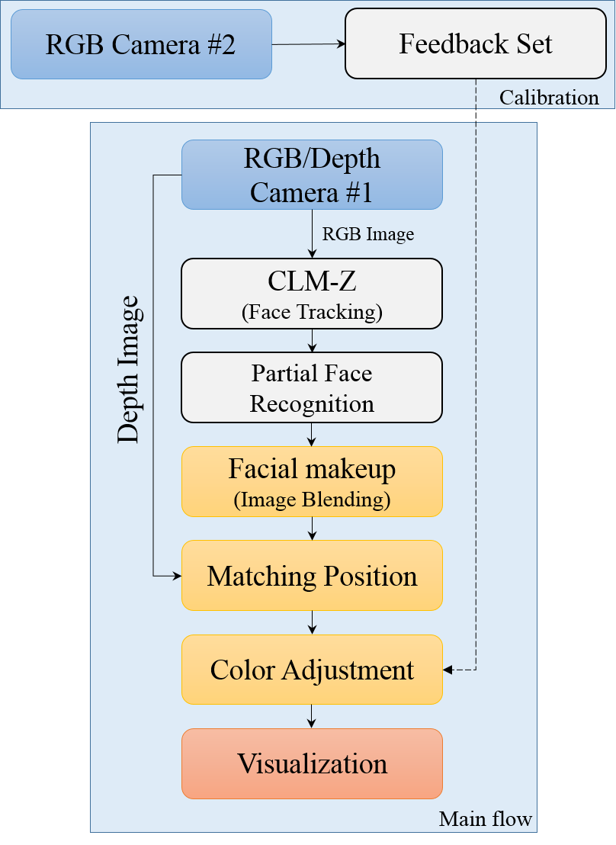
Figure 1. System Flow

A. Facial makeup

The virtual cosmetic system proposed in this paper is started from the ROI based image identification. The system estimates the position of the face, eyebrows, eyes, nose, mouth, and cheeks. It tracks the pupils to match the viewpoint and focus and makes the result with blending and changing color weight for natural image. The basic implementation direction is to extract feature points with algorithm based on the CLM-Z [7], and change color to the HSV format. With the area of feature points within the range, in the text, the contours are referred to as eyelashes, eyebrow halls, pupils, eyelash lines including underlays, underlines, noses, cheeks, lips, and face outlines. For this, simple color adjustments such as alpha blending or gradation are applied. In this process, a simple color blending with one-colored layer causes awkward facial makeup. Since the facial makeup always consider the curve and contrast of human face, the blending image with monochromatic color image, Figure 2. (c), as shown in Figure 2. (f), is not suitable for facial makeup. When the original image is converted to HSV format with changed hue value, Figure 2. (d) , as shown in Figure 2. (g), it is possible to express it while maintaining the overall contrast and bend. However, in this case, since only the hue of the original face image of the user is converted and applied, the output value is not suitable as the base image because it cannot satisfy enough coloring for makeup. Therefore, we convert base image to HSV format with adjusted saturation value, Figure 2. (e). The contrast of image is clearly shown. After all, we use HSV gradation with robust saturation image as shown in Figure 2. (h).

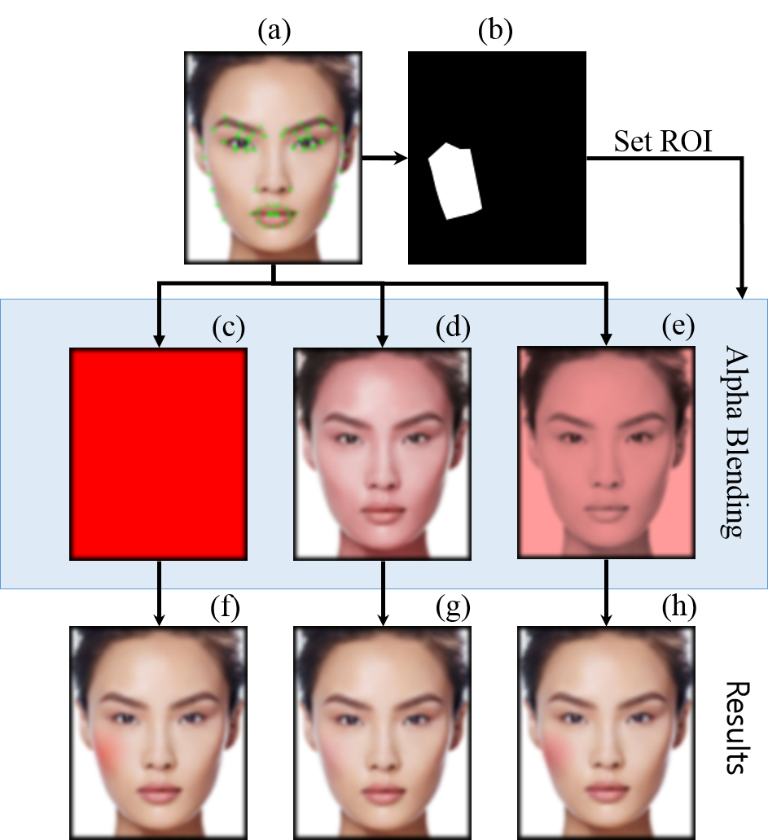

Figure 2. Makeup Images
(a) original image with partial feature tracking, (b) mask area of facial makeup (right cheek), (c) simple RGB color image, (d) hue-changed image, (e) saturation-changed image, (f) result of (a)+(c) blending, (g) result of (a)+(d) blending, (h) result of (a)+(e) blending.
"Best Contouring Makeup", SEPHORA [8]

B. Matching Position

Unlike the conventional full-virtual facial makeup system which simply outputs the face to the provided display or device and accepts information from the image, the virtual makeup system based on the focused augmented mirror needs to calibrate the image of the user reflected on the mirror and the image on the displaying device, back of the focused augmented mirror. It is necessary to match the two images of average face shapes and the distance between the device and the user with both the depth and the RGB camera image. The FAMirror for this facial makeup system doesn’t need to be a huge size, it doesn’t have enough depth of field, Figure 4. Therefore we only uses viewpoint matching for calibration without depth-of-field matching [1].

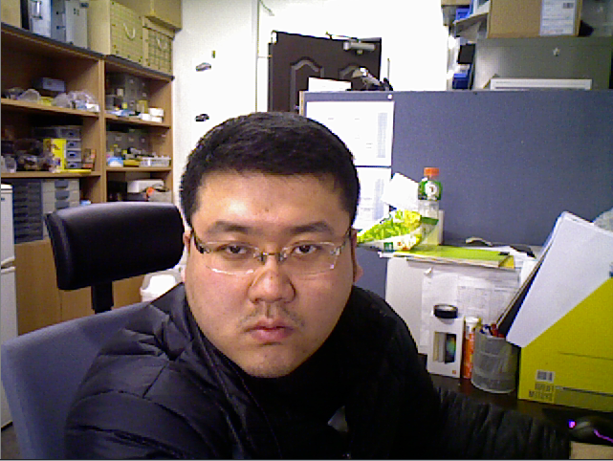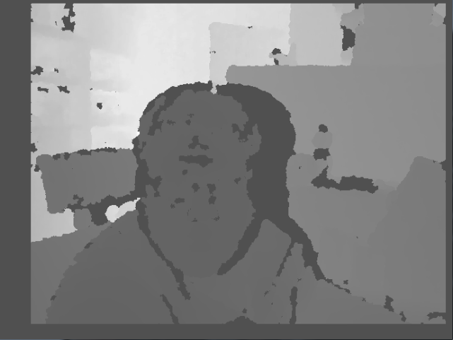
(a) (b) (c) (d)

Figure 3. Matching Position
(a) RGB, (b) position matched normalized depth image, (c) face-detected RGB, (d) position matched face-detected normalized depth image.

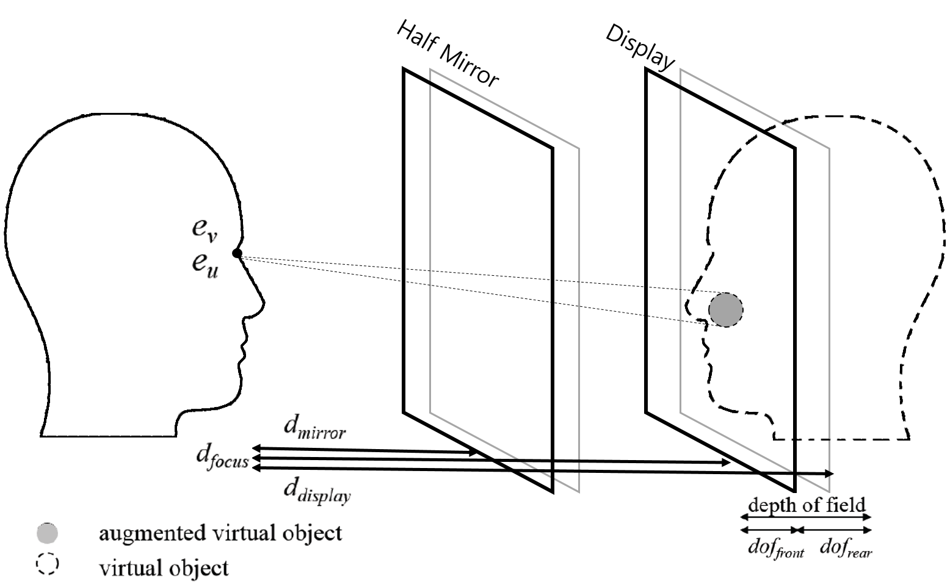
(makeup)
Figure 4. Depth-of-Field Matching in FAMirror

C. Color adjustment

There are some external factors which disturbs image processing, including the material of the object, the light, and the shooting angle of the camera. Since this focused augmented mirror-based facial makeup system is used indoors and is intended for user's facial makeup, we only concern about light in the general factors, and in particular, we should consider the inherent transmittance of the one-way mirror. The purpose of the color adjustment is to restore the original color data lost during the sequence of passing mirror from display device to user’s sight. The additional cam #2 installed in the direction of the focused augmented mirror on the front side of the device get the reflected original image. When using the system for the first time, we record the uncalibrated blended image projected on the mirror display with cam #2, and calculate the difference from the original value observed by cam #1, then we create a feedback set to act on the average. Since there is no dramatic environmental change, we build a system that allows continuous color adjustment without cam #2, except very first time.

The areas for comparison are two reasons-of-interest obtained through the face-detection algorithm, not the whole screen area. Because it is very hard to perfectly match the relative positions of cam #1 and cam #2, we use a simple color correction possible by comparing the average values of the area centered on the face. After ROI is specified, convert the image data of the corresponding area from RGB to HSV format, and calculate the average difference value of hue, saturation, and value of each area and create a basic feedback set. The system then uses this set of feedback to enable continuous color adjustment without cam #2.

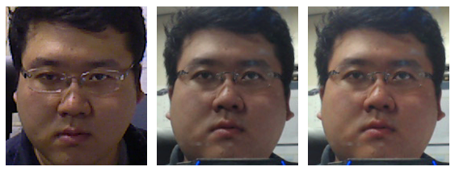
- (b) (c)
Figure 5. Color-adjustment Image
(a) original image shot by cam #1, (b) blended image on mirror shot by cam #2, and (c) color-adjusted image on mirror shot by cam #2.

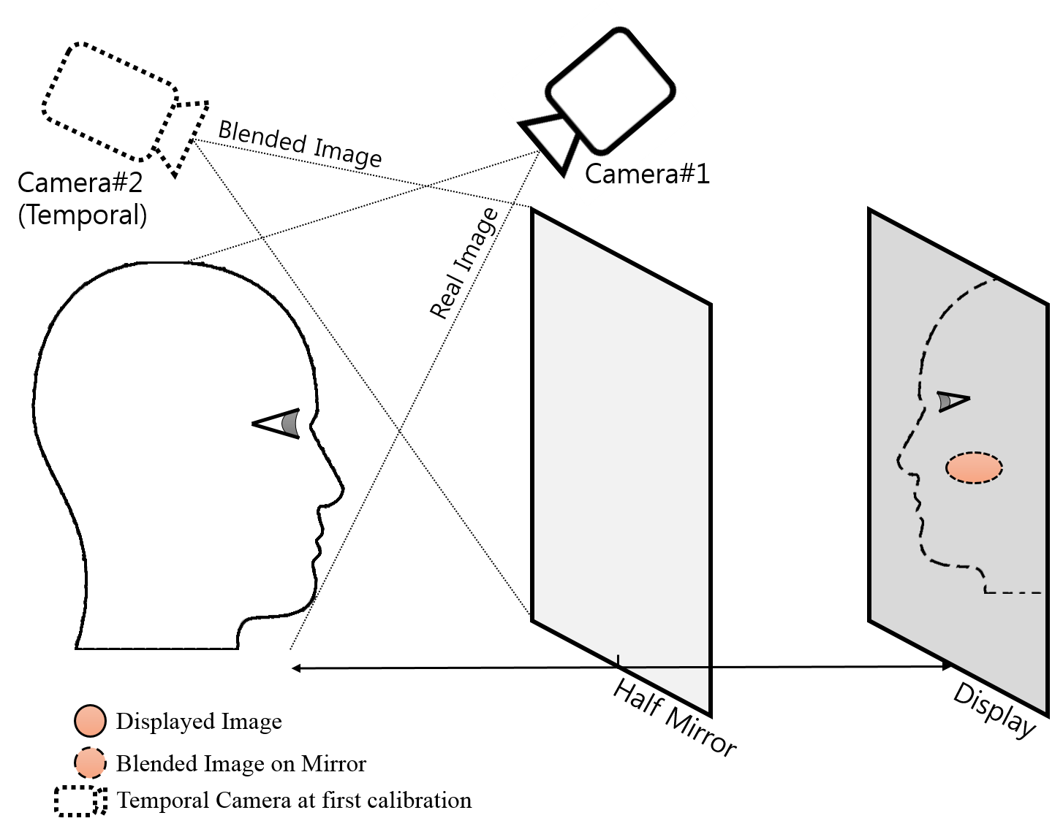
Figure 6. Hardware Configuration

IV. Conclusion

In this paper, we deal with a basic focused augmented mirror-based facial makeup content, which imposes a minimum sense of discomfort to the user. This can be referred to as the development type of the hardware for interaction. A mirror, often seen in everyday life, is perfect device which can provide the best homogeneous feeling to a user. As it is presented as a mirror, a direct device, the accessibility of this research is superior to other services that need to be passed through other applications or special virtual devices. Also, it can be expected to develop into a form that can be easily provided through optimization and cost-down.

However, in this paper, since feedback that can be provided to the user is limited to the only focused augmented mirror and color adjustment, there is room for further improvement like feedback based on the difference of main/auxiliary eye of the stereo vision of human, or recognizing hand gestures using the depth image on the focused augmented mirror system. It is expected that the color adjustment, which is used to correct the average error over the current area in this paper, can improve the quality of the correction by making and using individual conversion equations for each color, not the abstract average values. It can provide the best research for the user.

Acknowledgment

This work was supported by the National Research Foundation of Korea funded by the Korean Government (NRF-201609120). This research is supported by Ministry of Culture, Sports and Tourism (MCST) and Korea Creative Content Agency (KOCCA) in the Culture Technology (CT) Research & Development Program (Immersive Game Contents CT Co-Research Center).

References

[1] Jae Seok Jang, Soo Ho Choi, Gi Sook Jung, Soon Ki Jung, Focused augmented mirror based on human visual perception, The Visual Computer, Vol.32, pp.1-12, 2016.
[2] Oztel, Gozde Yolcu, and Serap Kazan. "Virtual Makeup Application Using Image Processing Methods." International Journal of Scientific Engineering and Applied Science (IJSEAS), Vol.1, No.5, pp.401-404, 2015.
[3] Scherbaum, K., Ritschel, T., Hullin, M., Thormählen, T., Blanz, V., & Seidel, H. P. "Computer‐Suggested Facial Makeup." Computer Graphics Forum, Vol. 30, No. 2, pp. 485-492, 2011.
[4] Jae Seok Jang, Gi Sook Jung, Tae Hwan Lee, Soon Ki Jung, Two-Phase Calibration for a Mirror Metaphor Augmented Reality System, Proceedings of the IEEE, Vol.102, No.2, pp.196-203, 2014.
[5] Yamaguchi, M., Teraji, T., Ohsawa, K., Uchiyama, T., Motomura, H., Murakami, Y., & Ohyama, N. "Color image reproduction based on multispectral and multiprimary imaging: experimental evaluation." In Electronic Imaging 2002, pp.15-26, 2002.
[6] Chen, X., Yang, X., Xiao, S., & Li, M. "Color mixing property of a projector-camera system." 5th ACM/IEEE International Workshop on Projector camera systems, p.14, 2008.
[7] Baltrušaitis, Tadas, Peter Robinson, and Louis-Philippe Morency. "3D constrained local model for rigid and non-rigid facial tracking." Computer Vision and Pattern Recognition (CVPR), 2012 IEEE Conference on. IEEE, pp.2610-2617, 2012.
[8] "Best Contouring Makeup", SEPHORA,
http://www.sephora.com/best-contouring-makeup.

